Project Planning Phase
Project Planning Template (Product Backlog, Sprint Planning, Stories, Story points)

Date | 20 February 2026
Team ID | LTVIP2026TMIDS82444
Project Name | Measuring the pulse of prosperity: an index of economic freedom
Maximum Marks | 5 Marks

Product Backlog, Sprint Schedule, and Estimation (4 Marks)
Use the below template to create product backlog and sprint schedule
Sprint | Functional  Requirement  (Epic) | User Story  Number | User Story / Task | Story Points | Priority
Sprint-1 | Data Analysis & Visualization | USN-1 | As a Policymaker, I want to view a world map showing economic freedom scores by country, so that I can quickly identify regions with high or low economic prosperity and potential policy impact areas. | 2 | High
Sprint-1 | Data Analysis & Visualization | USN-2 | As an Economic Researcher, I want to filter economic data by specific years and countries, so that I can conduct in-depth analysis on historical trends and compare performance across different nations. | 2 | High
Sprint-1 | Data Analysis & Visualization | USN-3 | As an Investor, I want to see the top 40 and least ranked countries based on their economic index, so that I can identify potential investment opportunities or risks in various markets. | 4 | High
Sprint-2 | Data Ingestion &  Management | USN-4 | As a User, I want to upload new economic datasets (e.g., CSV, Excel), so that I can incorporate the latest information into the analysis and update the index | 3 | Medium
Sprint-2 | Data Analysis & Visualization | USN-5 | As an Economic Researcher, I want to view correlations between economic freedom and indicators like unemployment rate and GDP growth, so that I can understand the multifaceted impacts of economic policies. | 4 | High
Sprint-3 | Reporting & Export | USN-6 | As a User, I want to export visualizations (e.g., charts, maps) as image files, so that I can easily include them in presentations or reports. | 4 | Medium
Sprint-3 | User  Management &  Authorization | USN-7 | As an Administrator, I want to manage user accounts and roles, so that I can access levels to sensitive data and functionalities. | 3 | High

Project Tracker, Velocity & Burndown Chart: (4 Marks)

Sprint |  | Total  Story  Points | Duration | Sprint Start Date | Sprint End  Date (Planned) | Story Points  Completed  (as on  Planned End  Date) | Sprint Release Date (Actual)
Sprint-1 |  | 8 | 5 Days | 16 June  2025 | 21June 2025 | 6 | 21 June 2025
Sprint-2 |  | 7 | 5 Days | 21June 2025 | 25 June 2025 | 7 | 25 June 2025
Sprint-3 |  | 7 | 5 Days | 25 June  2025 | 30 June 2025

Velocity:
Imagine we have a 10-day sprint duration, and the velocity of the team is 20 (points per sprint). Let’s calculate the team’s average velocity (AV) per iteration unit (story points per day

AV = sprint duration/velocity =15/10=1.5

Burndown Chart:
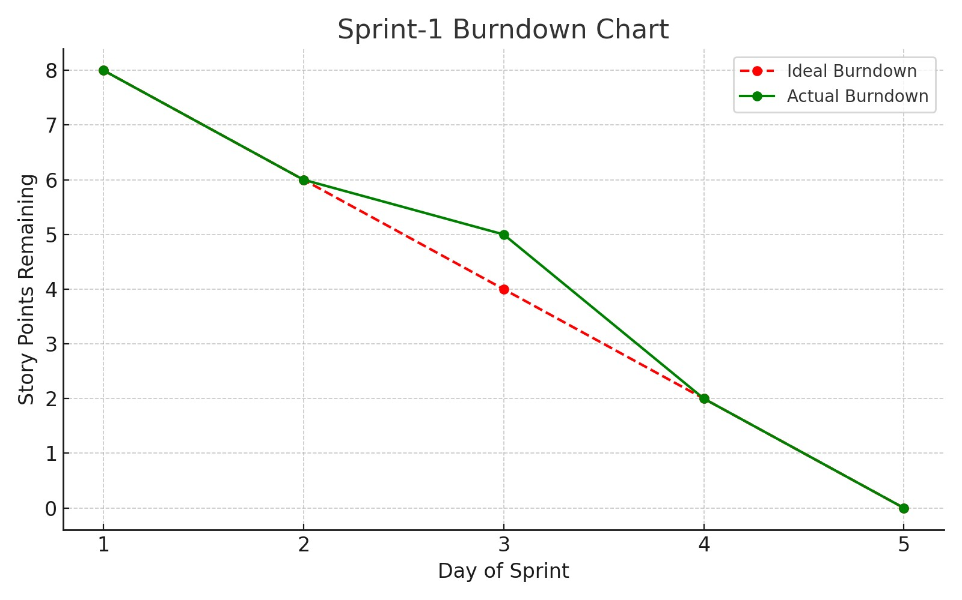

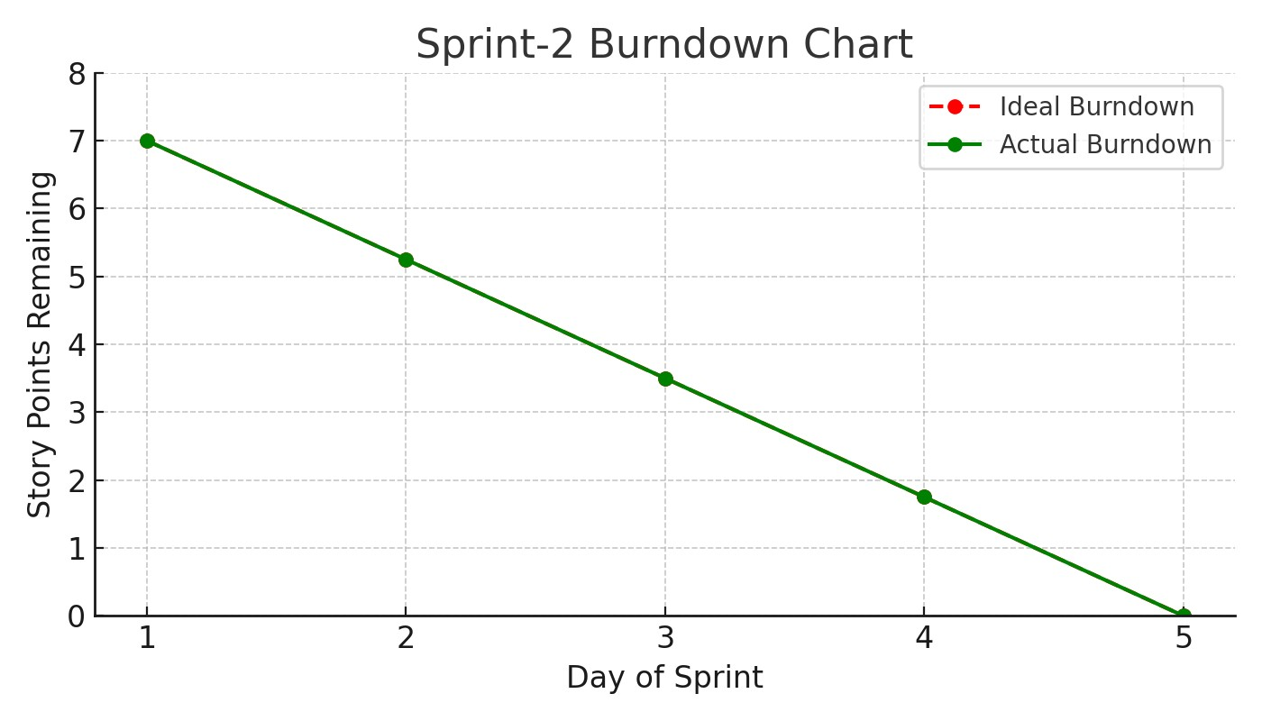

https://www.visual-paradigm.com/scrum/scrum-burndown-chart/
https://www.atlassian.com/agile/tutorials/burndow
n
-
chart
s

